The Impact of Climate Change on High-Altitude Glacier

*A Case Study on Guoqu Glacier, Qinghai, China*

Donglai Yang

GLY 547 Midterm Project

April 18, 2022

**Summary**

Glaciers at high altitude mountains around the Tibetan Plateau are precious freshwater resources for downstream ecological systems and human settlements. A recent study (S. Kang et al., 2015) on the ice core geochemistry suggests that significant ablation has occurred in the past twenty years near the ice divide of Guoqu glacier, one of many in the northeastern Tibetan plateau. In this study, I use a flowline model to simulate the changes in surface mass balance constrained by the ice core chronology and, assuming the same climate change trajectory, project the ice loss into the future. The modeling results show a staggering migration rate of Equilibrium Line Altitude (ELA) (at least 18 m per year) and has rendered the glacier entirely ablated. At such a rate, the glacier will likely lose half of its existing mass in 2100. Given such impact, future works on alpine glaciers at high altitudes should focus on constraining the changes in climatology.

**Background and Motivation**

Anthropogenic climate change is argued to be amplified at higher altitudes (S. Kang et al., 2015; Shichang Kang et al., 2010), yet due to the difficulty in acquiring in situ measurement, the implication of dramatic warming at high altitude is poorly understood. Geochemistry as proxies of past climate change from ice cores can provide insights into flow dynamics and mass balance. A study on the ice core retrieved from high elevation (~5800 m a.s.l.) at Guoquo Glacier, Mt. Geladaindong in Qinghai, China, reveals an intriguing tracer chronology. Researchers found chemical signals from 1982 Galunggung volcanic eruption in Indonesia, but no radioactive isotopes from Chernobyl nuclear disaster in 1986, along with an abrupt end of mercury contents in the late 80s representative of regional emission. This implies that significant ablation has taken place at the coring site that melted away the accumulated snow layers after 1982 (or sometime before 1986).

This narrow time window could constrain how much and, under certain assumptions, how fast the climate has changed. Using a numerical glacier model with basic meteorological variables such as ELA and lapse rate allows us to inversely determine the possible trajectory of climate change at the glacier, which as an independent estimate adds to the existing spare meteorological measurements at high altitude. Numerical modeling can additionally project the change in ice volume under various climatic conditions in the future and inform the local policymaking.

Figure 1 The location of Guoqu glacier and lateral profile. Top: The location of the Guoqu Glacier on Landsat images. The red rectangular box locates the glacier on a larger regional map of Tibetan Plateau. Bottom: the lateral profile of the glacier in 1982. The artifact of sharp undulations of the surface elevation is due to the smoothing of the bed elevation.

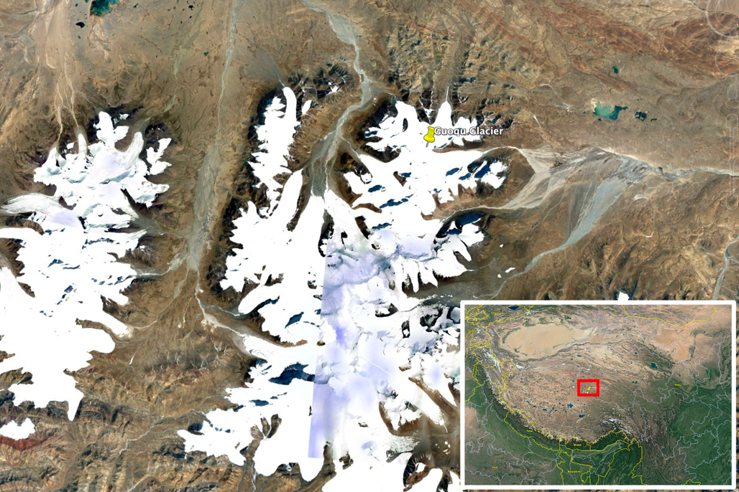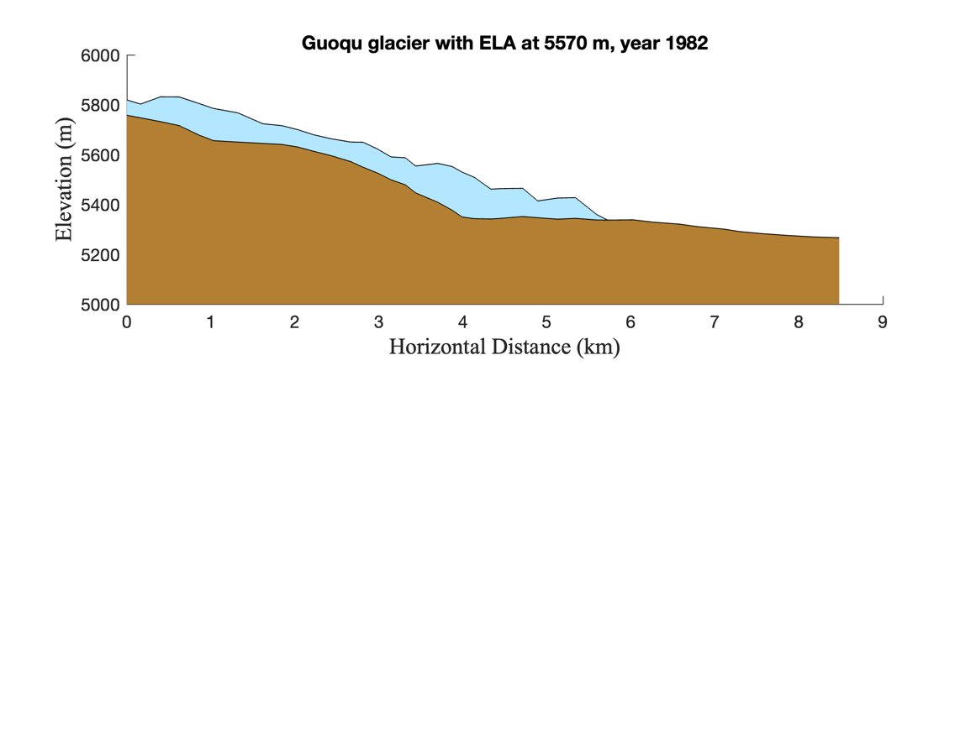

**Research Questions**

The ultimate question I wish to answer is: how has climate change impacted Guoqu Glacier and how will the current climate change trajectory impact it in the future?

The questions I need to answer along the way are:

1. What was the climatology (in this case, lapse rate) at early 1980s?
2. What are the possible climate change scenarios between 1986 and 2006 at the site that can produce the ice core chronology?
3. What is the projected ice loss at Guoqu Glacier in 2100?

These three questions also outline the structure of this study, from initializing the model to solving for climate change scenarios and then projecting future changes.

**Datasets**

I obtained the surface Digital Elevation Model (DEM) from NASADEM project which is derived from the Shuttle Radar Topography Mission (SRTM) data. It is publicly available at OpenTopography(<https://portal.opentopography.org/datasetMetadata?otCollectionID=OT.032021.4326.2>). The ice thickness data comes from Millan et al., 2022, which computes ice thickness from ice flow velocity data assuming shallow-ice approximation. It is also publicly available at Sedoo(<https://www.sedoo.fr/theia-publication-products/?uuid=55acbdd5-3982-4eac-89b2-46703557938c>). The bed topography is derived by subtracting the ice thickness from surface DEM. ELA in early 1980s is reported in (Zhang, 1981).

**Methods**

**Shallow-Ice Approximation**

I use the Shallow-Ice Approximation (SIA) to model the evolution of Guoqu Glacier. SIA assumes driving stress is balanced by vertical shear deformation and ignores longitudinal stress gradient, which is reasonable for a land-terminating glacier. The ice-bed boundary is non-slip and since it is a 1-D flow line model, I do not consider lateral drag.

I can describe SIA in mathematical terms as

$$u\left(H\right)=\frac{2A}{n+1}{\left(ρgα\right)}^{n}H^{n+1}$$

( 1 )

$$\frac{∂H}{∂t}+\frac{∂(uH)}{∂x}=\dot{b}$$

( 2 )

Where the first equation describes the surface velocity $u$ as a function of ice thickness $H$, surface slope $α$, and the second equation describes mass conservation, a.k.a, continuity equation. $A$ is softness parameter ($3.8×{10}^{-24} Pa^{-3}s^{-1}$), $ρ$ is the density of ice ($917 kg/m^{3}$), $g$ is gravitational constant ( $9.8 m/s^{2}).$ $\dot{b}$ is the net accumulation rate ($m/yr)$. $n$ is the nonlinearity exponent in Glen’s flow law, a constitutive equation describing the relation between stress and strain rate, specifically

$$\frac{1}{2}\frac{du}{dz}=A{\left(τ_{xz}\right)}^{n}$$

( 3 )

Where $τ_{xz}$ is the vertical shear stress. For this study, I assume n = 3.

The net accumulation rate is assumed to be a function of altitude, such that

$$\dot{b}=\frac{db}{dz}[\left(H+Z_{b}\right)-Z_{ELA}]$$

( 4 )

Where $Z_{b}$ is the elevation at the bed, $Z_{ELA}$ is the ELA, and $\frac{db}{dz}$ is the precipitation lapse rate or net mass balance gradient ($\frac{\frac{m}{yr}}{m}$).

**Model Initialization and Error Metrics**

To determine the initial climatology at around 1980, I must find the net mass gradient $\frac{db}{dz}$ that minimizes the simulated ice thickness and the observation. I use mean square error to quantify the difference, or specifically

$$MSE= \frac{1}{n}\sum_{i=1}^{n}{{\left(H_{i}-{\overline{H}}_{i}\right)}^{2}}$$

( 5 )

Where $H_{i}$ is the thickness from the observation at location i and ${\overline{H}}_{i}$ is the simulated thickness at location i.

**Possible climate change scenarios, 1986-2006**

In this study, I assume that the lapse rate and ELA increase or decrease linearly in time, or in mathematical terms

$${\frac{db}{dz}}_{t}={\frac{db}{dz}}_{0}+λt$$

( 6 )

$$Z_{ELA_{t}}=Z_{ELA_{0}}+κt$$

( 7 )

Where ${\frac{db}{dz}}_{t}$ and ${ Z}_{ELA_{t}}$ is the lapse rate and ELA at time $t$ respectively, and ${\frac{db}{dz}}_{0}$ and $Z_{ELA_{0}}$ is the initial lapse rate and initial ELA respectively. $λ$ and $κ$ are the time rate change of lapse rate and ELA, respectively.

To determine the possible time rate change of these two climatological variables, I propose the following criterion:

$$\left\{\begin{aligned}\int_{1982}^{1986}{\dot{b_{0}}\left(x_{c}\right) dt }<\int_{1986}^{2006}{\dot{b}\left(x_{c},t\right) dt<0\text{ accept}} \\ Otherwise, \text{ reject}\end{aligned}\right.$$

( 8 )

Where $x_{c}$ is the location where the ice core was recovered. During 1982 and 1986, I assume the constant climatology; during 1986 and 2006, the net mass balance rate is a function of time as defined above. I accept the time-integrated mass balance that is negative over the past 20 years but meanwhile the ablation was not too much to melt away the amount accumulated between 1982 and 1986.

**Projected ice loss into 2100**

To project the ice loss from the present to 2100, I assume that the change in the climatology – in this case, the migration of ELA – remains at the same rate as during 1986-2006, and I further assume that the time rate of change of $\frac{db}{dz}$ remains zero, i.e., the precipitation lapse rate does not change in time.

I adopt the Monte Carlo method for probabilistic projection. It is a generative method to randomly sample a value from a distribution as a prior to a deterministic model. In our case, I assume a Gaussian distribution of time rate change of ELA, or

$$N\sim \left(μ, σ\right)$$

( 9 )

Where $μ$ is the “mean” here approximated as $(max(ELA) + min(ELA))/2$, the arithmetic mean from the max/min ELA values derived from equation (8); $σ$ is the “standard deviation” here approximated as $(max(ELA) + min(ELA))/4$, the 25% quantiles for a uniform distribution spanning the max/min ELA values derived from equation (8).

**Results**

To find the initial climatology in 1980’s, I initialize the model with the ELA found in literature, at ~5570 m a.s.l., and numerous lapse rate values to seek the minimal error with respect to the ice thickness observation.

Figure 2 shows the simulated and the observed ice thickness profiles (left) and the associated MSE (right). A global minimum marked by the orange circle and arrow is found where $db/dz$ is ~0.00013 m/yr, which is very close to the independent estimate at 0.00019 m/yr(Cuo & Zhang, 2017). As a reference, the lapse rate for Mount St. Helen is roughly 0.007 m/yr/m, which is almost forty times larger than at Guoqu Glacier. This might come from the exponential decay of capacity to hold water in the air as temperature goes exponentially at a higher elevation.

Figure 3 shows the possible climate change scenarios between 1986 and 2006. The scenarios that do not satisfy the ice core chronology are rendered null, whereas the possible ones are colored from white to blue, indicating the time-integrated total net mass balance. It shows that while there is a wide range of possible ELA migration rates, the minimum is ~18.5 m/yr. A negative time rate change of lapse rate indicates flattening of the gradient. As the time rate change of lapse rate becomes more negative, a faster ELA migration rate is required to ablate the snow more quickly at the drilling site, creating this crescent shape. Conversely, if the lapse rate is steepening over time, less ELA migration is needed to cause significant ablation. Without further regional climate modeling input or theoretical knowledge, it is difficult, if not impossible, to determine which is the likely evolutionary path of the lapse rate under the warming climate.

db/dz (m/yr/m)

Figure 2 Model initialization. Left: simulated (solid color) and observed (dash blue) ice thickness profiles. Right: Mean Squared Error (MSE) as a function of db/dz. The orange circle and arrow indicate the global minimum.

The orange triangle outlines the range of time rate change of ELAs when there is no change in the lapse rate. I adopt these ELA migration rates as the basis of our Monte Carlo simulations. Figure 4 shows the projected ice loss volume, percent ice loss, and the glacier length in 2100. I estimate the $0.37 ±0.02 km^{3}$ assuming an average glacier width of 1.5 km, or a loss of $55 ±3 \%$ of the initial ice volume. The glacier length in 2100 has a gaussian-like distribution (anticipated as the prior distribution is gaussian) at $5735 ±30 m.$ From a simple measurement on Google Earth Pro, I estimate the present-day glacier length to be around 5900 meters, and hence the retreat is around 165 meters.

Net mass balance (m)

Figure 3 Possible climate change scenarios. White to blue squares are possible combinations of time rate changes of db/dz and ELA. The color bar shows the time-integrated net surface mass balance. The orange stripe is a slice of the matrix where db/dz does not change over time. It serves as the basis for the projection modeling.

**Conclusions and Effects on Society**

**­­­**Our modeling study on the past climate change at Guoqu Glacier, Qinghai, China, reveals fast migration rates of ELA toward higher altitudes, at a worrisome speed of at least 18 m/yr. The glacier at the present is entirely situated in the ablation zone. Assuming the same rate of climatic change, I project the ice loss into the 22nd century and find that the glacier will experience substantial ice loss. It may lose half of its existing volume and retreat over 150 meters.

Alpine glaciers are crucial freshwater resources. An accelerating loss can create anonymously high discharge rates and poses challenges to downstream flooding management and irrigation system, followed by a depletion of fresh water (Shichang Kang et al., 2010). Given the uncertainty in our analysis and the relevance of alpine glaciers to society, future studies on the climatological changes at high altitudes are warranted to deliver a more precise and accurate estimation for better hazard planning.

Fraction of original ice volume

Figure 4 The projected ice loss and glacier length at 2100. Left and Middle: Monte Carlo simulations with a gaussian prior on ELA migration rate project significant ice loss, at 0.37 $±$ 0.02 km^3, or a loss of 55 $±$ 3 % of the initial ice volume. Right: the glacier length at 2100 is projected to be 5735 $±$ 30 m. Compared to the original length at 2010 (5900 m), it retreats about 165 meters.

**Reference**

Cuo, L., & Zhang, Y. (2017). Spatial patterns of wet season precipitation vertical gradients on the Tibetan Plateau and the surroundings. *Scientific Reports*, *7*(1). https://doi.org/10.1038/s41598-017-05345-6

Kang, S., Wang, F., Morgenstern, U., Zhang, Y., Grigholm, B., Kaspari, S., et al. (2015). Dramatic loss of glacier accumulation area on the Tibetan Plateau revealed by ice core tritium and mercury records. *Cryosphere*, *9*(3), 1213–1222. https://doi.org/10.5194/tc-9-1213-2015

Kang, Shichang, Xu, Y., You, Q., Flügel, W. A., Pepin, N., & Yao, T. (2010). Review of climate and cryospheric change in the Tibetan Plateau. *Environmental Research Letters*. Institute of Physics Publishing. https://doi.org/10.1088/1748-9326/5/1/015101

Millan, R., Mouginot, J., Rabatel, A., & Morlighem, M. (2022). Ice velocity and thickness of the world’s glaciers. *Nature Geoscience*, *15*(2), 124–129. https://doi.org/10.1038/s41561-021-00885-z

Zhang, L. (1981). Glaciers at the source region of Tuotuo River in the upper reaches of the Changjiang (Tangtze River) and their evolution. *J. Glaciol. Geocryol.*, (3), 1–9.